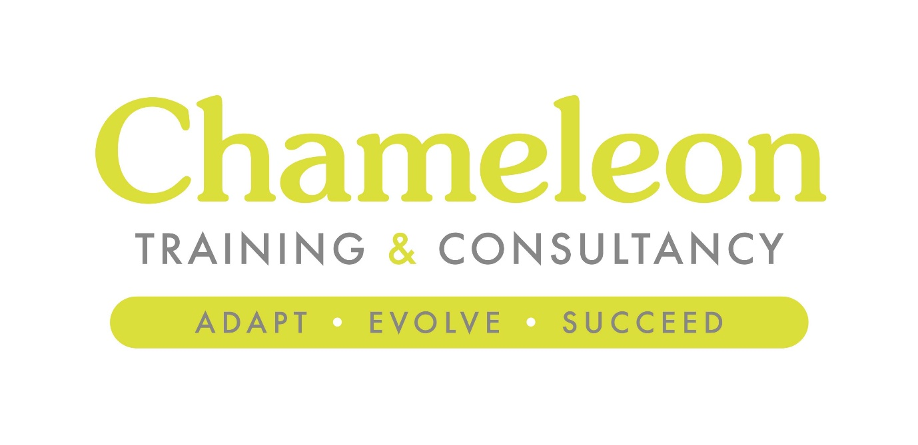

Income Generation
A strategic approach to
Fundraising and Bid Writing

Version 1
2021-2023

Executive Summary

Up front and personal, the Executive Summary sits at the start of your document and really does set out very clearly the purpose of your school income generation plan, presenting the main objectives and recommendations. It also serves to remind those responsible for its implementation of the original aims and objectives, preventing “mission creep” and providing a useful way to reflect and record success, or otherwise.

Our intention is to develop a coherent and structured approach to fundraising and income generation. The purpose of this document is to help focus on the current and future needs of the school and the resources at its disposal whilst identifying appropriate funding streams and opportunities. It is also important that we reflect on the success or otherwise of our funding activities to help improve and inform future bid writing.

We aim to be outward looking, client focused and responsive to change, providing the very best education experience for our young people. The strategy will specifically work towards these core objectives:

Situational Analysis

The situational analysis or “environmental scanning” part of the plan is designed to help identify your strengths and challenges. The idea is to analyse, understand and define current and future environments that the organisation will be operating within.

There are a number of analytic tools to help articulate this but essentially, you’re trying to gain intelligence on the external environment and your capability to thrive within that environment.

SWOT Analysis

Analysis of Strengths, Weaknesses, Opportunities and Threats reflecting the current position of the school providing a critical review of the internal factors which affect our position and the external factors which offer opportunities and threats to our development.

Strengths | Weaknesses
Opportunities | Threats
- .

Implications

Co-ordinated approach – the strategy will encourage a focused approach to whole school fundraising ensuring appropriate resources (time, effort, people) are allocated as necessary to maximise success. The strategy should feed into and be part of school development plans.

What have we learned from our SWOT analysis?

Gap Analysis

A GAP analysis can be used to evaluation or identify deficiencies, helping us to reach short term goals.

Our current position: An ad-hoc approach to business and operational fundraising strategy with perhaps a limited forward view.

Our desired position: To have a co-ordinated whole school plan overseen by a Committee or Group which engages with all stakeholders. The plan should be measurable and include key milestones. Strategically Governors and SLT will have sight of and input into the plan.
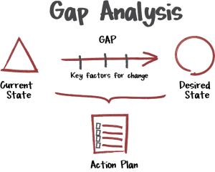

Desired State Specifically:

Strategic Planning

Strategic Planning (long term view = 4+ years)

Business Planning (medium term view = 2-4 years)

Operational Planning (shorter term view = 1 year)

Programme – Year 1 and 2

Focus- Year 1 Planning 2021 - 2022

Main Theme | Individual Action Points | Delivery Date

 | 1 | 2 | 3
Project Name
Cost (£)
Specific
Deliverables
Expected Impact
Evidence of Need

Resources
.

Support

Name | Current role | Support Offered
 |  | Fundraising lead
 |  | 2 IC Fundraising
 |  | Support and engagement, link between students, research, communications.
 |  | Link with alumni and advice/guidance.
 |  | Administration, database support, communications.
 |  | Potential partner, business link support for revenue streams.
 |  | SLT direction, guidance and support
 |  | Business links, historical contacts, knowledge and support.

Monitoring and evaluation

Issue | Feedback, lessons learned

`

Fundraising Totals – 2021-2022

Funder | Amount expected | By When

Reflection

Fundraising is a learning process. The difference between what an organisation believes is possible in the approval of the strategy, and what actually happens a few months in to its implementation are important to track and feed into future revisions of the strategy and its implementation. It is important that the whole organisation learns from this process so that fundraising is effective now and in the future.

Branding and Values

Value Mapping

Here we identify and understand culture and values. You’ll almost certainly have multiple objectives for your fundraising plan, and the plan should also sit alongside any marketing strategy you have in place. As such the purpose of the income generation may be, in part at least, to attract business partners and commercial sponsors so it is critical they understand and share your culture and ethos.

You’ll need to sharpen the vision for your school so it is crystal clear and simple to disseminate to others.

Defining core values can be a cathartic and transformational process and it needn’t be a complicated and drawn-out affair. You may find a mission statement is sufficient but a more visual and effective value mapping exercise can bring in the input key stakeholders involved in your offering.

Keep it simple – ask small focus groups (students and staff) to jot down their gut feelings about your school based around four themes; relationships, functional, beliefs and emotional.

Here you’re keying in some aspects of your school which make it unique; your relationships with key groups, the facilities available (functional), skills and knowledge (functional) and the key cultural drivers of your school (belief).

RELATIONSHIP | FUNCTIONAL
BELIEF | EMOTIONAL
You can use your new core values to define these messages, to distil them into no more than three key features of your offer, ensuring clarity on what positive impact this may have on any business partner.

Key Message 1

_______________________________________________________________

Key Message 2

_______________________________________________________________

Key Message 3
_______________________________________________________________

The Wheel of Fortune

There are various routes to generating additional revenue for your school and we can group them into these eight categories:

Donations – including those from our parents, visitors and former students (alumni). The new Gift Aid Small Donations Scheme (GASDS) allows charities to make claims on small donations of £20 or less without the need for obtaining a Gift Aid declaration from the donor. Gift Aid can be claimed on donations providing an additional 25% to the value of the donation – with exempt charity status schools can claim on payments retrospectively, for up to 4 years.

Opportunities/Action Points for Donations –

Grants – there are hundreds of grant funders willing to support schools and up to £1.5bn each year is awarded to education establishments by Trusts and awarding bodies.

However many schools fall at the very first hurdle when writing and submitting a funding bid by not ensuring their project meets the funders aims and requirements – over 45% of Awards for All Lottery grants for example are rejected at the very first stage. A cohesive and considered Income Generation Plan can ensure you are well placed to make sure your funding bids are as strong as possible.

One of our targets will be to upskill staff so they are best placed to write the school bid applications and maximise future success.

Opportunities/Action Points for Grants and Trust Fund applications –

Sponsorship – many local (and national) organisations have a natural desire to engage with schools. Some may do so for purely altruistic reasons, some may be attracted to accessing local talent pools for recruitment purposes whilst others may view the relationship as beneficial to its corporate social responsibilities (CSR).

Whatever the reasons, sponsorship agreements with business can provide real win-wins, with long term partnerships attracting sizeable revenue for the school.

Opportunities/Action Points for Sponsorship –

Lettings – utilising school facilities outside of hours can provide invaluable revenue. That said, most schools (almost 60%) still do not take advantage of their real-estate in this way, citing concerns around security, safety, insurance and caretaking as reasons for shying away from this potentially lucrative income source.

However, these risks can be managed, and once systems and procedures in place, hiring out facilities to local groups is definitely a sustainable income generator.

Opportunities/Action Points for Lettings –

Services – the operation of our schools involves a multitude of separate units, from printing and photography to catering and maintenance. With skilled staff, facilities and equipment, these services can be offered to local clubs, companies and the wider community.

Opportunities/Action Points for Services –

Events – hosting events can be time consuming and a fair amount of effort, but they are invaluable when it comes to raising the profile of the school and your fundraising aims. This is an area where you have to be careful with Effort V’s Reward.

Again, careful planning and preparation can help share the burden ensuring your events are not only successful but eagerly anticipated too!

Opportunities/Action Points for Events –

Clubs – the use of facilities by local sports clubs and social groups can be a useful source of income but schools must be conscious of their pricing structure – there is a tendency to offer facilities at overly-competitive rates – schools should be aware of their costs when setting and agreeing charges.

Opportunities/Action Points for Clubs –

Grants and Trust Funds

Hundreds of grants are available for the school to potentially exploit. Based on the initial assessment of the aspirations of these grants should be explored:

Name of Fund | Awarding Body | Amount available | Specifics (deadlines, criteria)

