EDUCISE
Actions speak louder than words!

Bounce

Bounce is game that can be adapted to suit a variety of subjects. It enables children to have the opportunity to improve their co-ordination and control skills as well as developing fast thinking.
Equipment
- 1 ball between 2+ pupils (table tennis ball, bouncy ball, plastic ball)
How to Play
- Get children into pairs or small groups.
- Pupils must bounce the ball back and forth across the table/ floor to each other while posing questions related to the given topic.
- Set some rules- For example for LA can have as many bounces as needed before answering the question, while HA only have 1 bounce.
- Use different methods of making the ball travel across the table/ floor e.g. rolling
How can this be used in the classroom?
- Numeracy – Times tables, mental arithmetic
- Literacy – Spellings, sentence structure, use of words

Pong
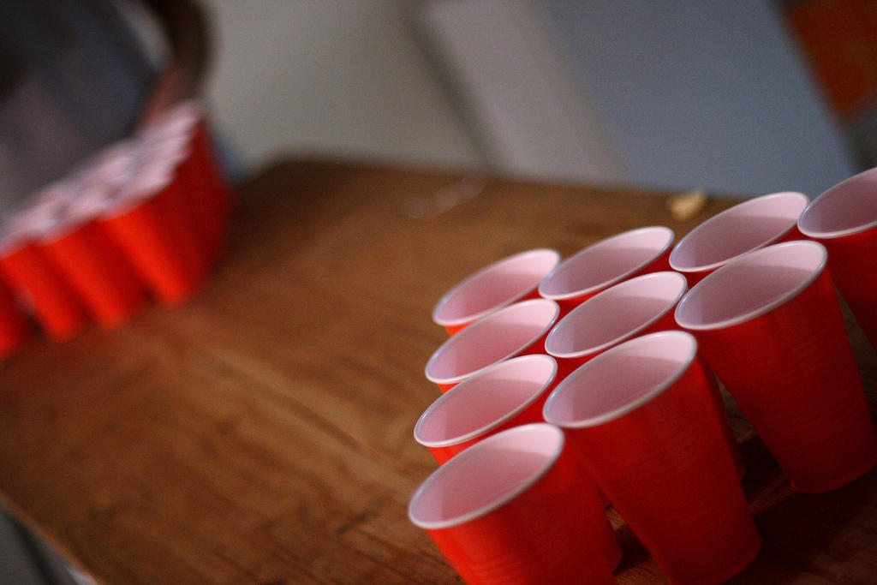

Pong is game that can be adapted to suit a variety of subjects. It enables children to have the opportunity to improve their co-ordination and control skills.
Equipment
- 1 table tennis ball between 2-4
- 6+ plastic cups or PE cones
How to Play
- Get children into pairs or small groups.
- Pupils try to bounce or throw the table tennis ball into one of their opponent’s targets. If they get the ball in, they must answer the question in the cup/ posed by the opponent to win that cup.
- Questions can be given to the group by the teacher or designed by the pupils themselves.

How can this be used in the classroom?
- Numeracy – Times tables, mental arithmetic
- Literacy – Spellings, sentence structure, use of words

Class Aerobics

Aerobics is an action based repetitive game, which enables children to improve cross lateral links in the brain which in turn will improve many of their gross and fine motor skills as well as co-ordination.
Equipment
- Music (If required)
- Open space/ space behind class places
How to play
- Children choose memorable actions to correspond with the topic of the learning.
- Increase children’s heart rate by performing the actions.
- Link the actions to questions which prompt recall.

How can this be used in the classroom?
- Numeracy- Times table recall, number bonds, linking inverse, mental arithmetic
- All subjects- Revising facts or story telling

Active Response

Active response is a fast paced reaction game where the children respond to a key word or sound. You can alter the way children move to the signs- allow them to challenge themselves and each other.
Equipment
- Signs
How to play
- Decide on how many signs you would like, and spread these out around the classroom.
- Children start in the middle of the room, and once a question is posed or a topic is set, the children must move to the corresponding answer.

How can this be used in the classroom?
- Phonics
- Literacy – Grammar focus
- Numeracy – Symbols, mental arithmetic
- All subjects- multiple choice questioning

Bucket Ball
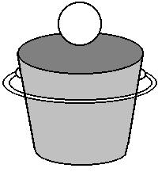

Bucket ball relies on the children’s aim to score the correct answer. Change the difficulty to create new levels to the challenging but exciting game.
Equipment
- Empty buckets/ trays
- Dry wipe balls/ bean bags
How to play
- Choose a topic, and create a series of questions related to this area.
- Children can either write their answers on the balls provided and throw/ place them into their designated team bucket or the buckets can be labellled A, B, C & D for multiple choice questioning.
- Ask the children a question, to which they respond by writing the answer on the balls and throwing them into the answer bucket, or for multiple choice questions throwing them into the corresponding bucket.
- You could also… label the balls before and ask children to sort the words, phrases or numbers into the categories.
How can this be used in the classroom?
- Numeracy
- Literacy
- Phonics
- All subjects- multiple choice questioning

What’s the letter Mr Wolf?

This is a simple game that can be used in any phonics or spelling lesson. Children hone in their skills of listening for the phonemes or blending the word to find out the spelling.
Equipment
- None
How to play
- One child is selected to stand at the front of the class facing away from the other children, while the others line up in a straight line.
- The child facing away says a letter, and if the other children have the letter in their word they can move one step towards the child (similar to What’s the time Mr Wolf).
- The winner is the first child to get to the front of the class.
- Pupil at the front could say the letter, sound the phoneme or write the letter on a whiteboard.
- Optional rule- if the wolf catches you moving you must return to the start.
How can this be used in the classroom?
- Early letter recognition
- Phonics
- Spelling

Jump to the left

Jump to the left is a simple game that can be used for a number of subjects to recall information using multiple choice questioning.
Equipment
- An open space
How to play
- Children given a space to stand in as neutral position e.g. behind their chair or lined up along the middle of the classroom.
- The teacher/ pupils need to agree upon some actions to represent multiple choice answers e.g. A= Touch head, B= Shoulders, C= Knees, D= Toes
- The teacher will pose a question related to a given topic which requires a multiple choice answer. Each of pupils must answer with an action once the teacher counts down 3, 2, 1.
- Challenge the pupils by getting them to perform actions while they wait for the next question e.g. star jumps etc.

How can this be used in the classroom?
- Any subject- multiple choice questioning/ plenary

Race Car
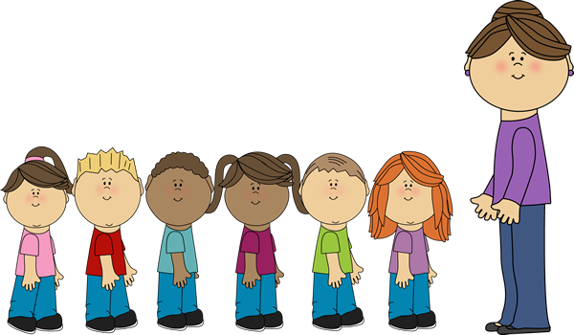

Overtake your group to become the race leader, and drive yourself to learning success. A competitive game that allows children to test their knowledge.
Equipment
- A set of questions and answers related to the chosen topic.
- Optional step/ chair.
How to play
- Split pupils into groups, with each group having a question master.
- The participants stand in a single file line, with the question master standing facing them (on a step or chair if required).
- The question master will read out the questions one by one. The participants must raise their hand as soon as they know the answer (however they can only answer once per question).
- Whoever raises their hand first gets the chance to answer the question. If this pupil gets the answer correct, they get to overtake the person in front of them in the line. However if the pupil gets the answer wrong, they must move back a space within the line.
- The winner is the pupil who is at the front of the line at the end of the game.

How can this be used in the classroom?
- Any subject- recall of information/ test of knowledge.
Rob the nest
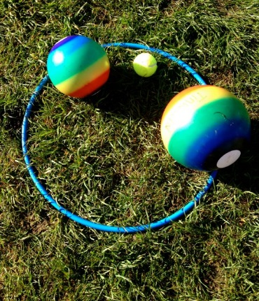

A strategy game that requires teamwork, speed, knowledge and communication.
Equipment
- Topic cards
- Tray, table or hoop
How to play
- Split the class into teams
- Create some topic cards for your chosen area of learning. The cards are placed face down in the middle of the class.
- When the game begins, one pupil per team may run to the middle of the room to collect a card, and take it back to their group to answer.
- Optional- Once all of the cards have been taken from the middle of the class, pupils can start to steal cards from other teams.
- Alternative- Set pupils a target using the cards e.g. letters on each card, create a word with 5 letters.
How can this be used in the classroom?
- Literacy – Spelling, grammar
- Numeracy- Calculations, times tables
- Any subject- questioning

Question ball

Ask your questions now! Use balls to throw questions around your classroom and have them answered.
Equipment
- Plastic Ball and dry wipe pen or screwed up paper.
How to play
- Choose a topic for the game.
- Children write a question related to the topic on their paper or ball/ ask when in possession of the ball. They then must throw their question to another member of the class to answer. If this pupil successfully catches the question, they have a chance to answer the question.
- Optional- The pupil who correctly answers the most questions wins in time limit wins.
- Optional- If the pupil gets the answer correct, they may write the next question and throw to the next player. However if the pupil gets the answer wrong or does not catch the question, they must throw the question straight on to another person within the class.
- Challenge the pupils by introducing more than one ball, or by creating a scoring system to add a competitive edge.
How can this be used in the classroom?
- Any subject- Questioning

Balloon Rally

Think fast to keep the balloon in the air- don't let it touch the ground!
Equipment
- Balloons
How to play
- Split the class into pairs or small groups, with each of the groups being given a balloon.
- The game is to keep the balloon in the air whilst answering a series of questions (a question master per group may be beneficial).
- The questions will be asked/ answered one by one around the group. The active participant can only touch the balloon to keep it up once they have correctly answered the question posed to them.
- Each participant starts with 3 lives. If the balloon hits the floor when it is your turn to answer, you lose a life.
How can this be used in the classroom?
- Numeracy - Times tables or number bonds
- Literacy – Spelling, grammar
- Any subject – Short multiple answer questioning

Around the world

Make your way around the class to become the champion!
Equipment
- None
- Optional- White board
How to play
- The teacher will read out questions related to the chosen topic.
- One pupil is selected to be the reigning champion and must stand behind the pupil at the start of the journey.
- Teachers ask the 2 participating pupils a question, the first one to shout the answer/ write the answer wins and moves on to the next pupil on the journey.

How can this be used in the classroom?
- Numeracy – Calculation, mental arithmetic
- Any subject – Multiple choice/ closed questioning

Kung Fu Punctuation

A combination of kung fu movements and punctuation skills. Children get the opportunity to attack the unpunctuated sentences.
Equipment
- A piece of text
- Agreed Kung Fu actions corresponding to punctuation symbols
How to play
- Children stand in a space within the classroom, or behind their chairs.
- A number of Kung Fu actions are agreed prior to the game beginning.
- A sentence/ piece of text is shown on the white board and children have to read along with the teacher putting in the correct punctuation to make the sentences grammatically correct.
- Each time a certain piece of punctuation is required in the text, the pupils must perform the corresponding action e.g. punch the air for a full stop.
- This could be adapted for other symbols in different subjects e.g. numeracy.
How can this be used in the classroom ?
- Literacy – Punctuation, features of a story/instruction
- Numeracy – Calculation

Hot Potato

An energetic throwing game that requires quick hands, and even quicker thinking!
Equipment
- A ball/ object which can be thrown around the room
How to play
- The teacher chooses a topic for the game.
- The teacher starts with the hot potato, and poses a question with a range of possible answers e.g. times tables.
- The teacher must then throw the hot potato to someone else within the class, who must then give an answer to the question, before throwing the hot potato onto the next player.
- If a pupil gets an answer incorrect, or take too long to come to an answer, the pupils can either be eliminated, or face a forfeit of some kind e.g. go down to one knee, or lose a life.
- This game can be adapted so that the questions only require one answer, and the pupil who catches the hot potato must then pose the next question to the group.
- In addition, it can be adapted so that rather than answer questions, each child must say a word or piece of punctuation when they receive the hot potato, in order to create a short story.
How can this be used in the classroom?
- Literacy – Spelling, grammar, sentence structure/ short story telling.
- Numeracy – Calculation, times tables, mental arithmetic, number bonds
Million pound drop

A TV favourite coming to life in your classroom!
Equipment
- Fake money/ objects to represent money (multi-link cubes, balls, beanbags)
- Empty trays
How to play
- Pupils work individually or in groups
- Each participant has a set of fake money totalling £1m (e.g. each money card/ multi-link square= £100,000). Trays are set out at the front of the class and are labelled A, B, C & D.
- A series of multi-choice questions and answers are read out/ displayed on the screen. Pupils must answer the questions by going to the front and putting their ‘money’ into the answer trays before the time runs out. Pupils can put all the money in one tray, or alternatively can spread the money around more than one tray.
- Any money in the incorrect answer tray is taken away for the next round and so on.
- Optional- pupils can throw the object into the tray, if they miss, the money is taken away.

How can this be used in the classroom?
- Any subject – Multiple choice questioning

The Chase

A TV favourite coming to life in your classroom!
Equipment
- Floor spots/ mats or pieces of paper
- Mini whiteboard and pen
How to play
- Participants can work individually or in groups. The ‘Chaser’ can be an individual or group. Both have a whiteboard and pen to answer questions.
- A number of floor spots are set out on the floor in a straight line. The participant(s) choose whether to start easy, medium or hard (3 spots, 2 spots or 1 spot away from the chaser respectively).
- A series of multi-choice questions are asked by the question master. If a participant/ chaser get the answer correct, they can jump forward to the next spot. If they get the answer wrong however, they must remain on the spot they’re on.
- If the chaser catches the participant, the game is over. However, if the participant manages to get all the way to the end without being caught, they win and are rewarded based on the difficulty selected.

How can this be used in the classroom?
- Any subject – Multiple choice questioning

