 | x  78  76  75  73  71  72  70  74  77 | sh | ew | ou | 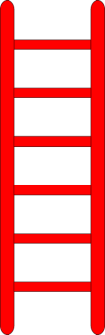  wh | ee | i_e | a_e | zz
61  63  64  66  68  67  69  65  62  60  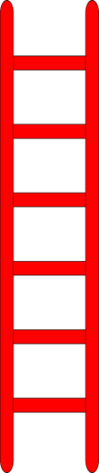  ch | cr | ai | ph | ck | oo | ew | ure | ff | br
air  58  56  55  53  51  52  50  54  57  59 | ur | ay | ey | ir | igh | ea | ll | u_e | tw
ss  41  43  44  46  48  47  49  45  42  40 | nd | scr | sp | sk | au | str | ir | ar | gr
ng  38  36  35  33  31  32  30  34  37  39 | or | o_e | ow | ie | oy | aw | ue | ear | fry
sn  21  23  24  26  28  27  29  25  22  20 | igh | dry | dr | or | ew | oe | cry | ie | oa
e_e  18  16  15  13  11  12  10  14  17  19 | er | ue | ure | aw | oo | ur | sp | br | oi
1  3  4  6  8  7  9  5  2  0 | ai | ee | ea | wh | a_e | ph | j | ck | th
Go up the ladders and down the snakes
You must correctly read the digraph or consonant blend you have landed on, before you can roll again.
You need:
1 x dice
Counter for each player (up to 4)
paper and pencil each

Rules
- All players start on the arrow.
- Roll your dice to get a number and move your counter along, following the numbers on the board in order.
- When a player lands on a digraph or trigraph, all players must race to write a word containing that digraph or trigraph.
- The game ends when a player reaches the star at the top of the board.
- Count up how many words you had containing digraphs and trigraphs, did you get the most?

